

Contents

CHAPTER 1: STATE THE PROBLEM. 2

CHAPTER 2: IDENTIFY DATA 3

CHAPTER 3: CUSTOMER SERVICE’S REPORT 5

**3.1 Overview of Customers and Assets:** 5

**3.2 Customer situation by segment** 6

**3.3 Customer situation by region:** 7

**3.4 Customer situation by service:** 10

# **CHAPTER 1: STATE THE PROBLEM.**

VP Bank branch director requested an overview report on the branch’s service usage and customer behavior.

The goal is to assess customer segmentation and identify which financial services can be leveraged to increase revenue by 20% in the next quarter.

This report will analyze customer distribution, service usage, and potential upselling strategies.

# **CHAPTER 2: IDENTIFY DATA**

**Relational Data Model**

The dataset includes three main tables: aum (customer assets), cust (customer segmentation and location), and prod_holding (product usage). The relational data model connects these tables via customer_id, allowing analysis of financial behavior across different customer segments and regions.

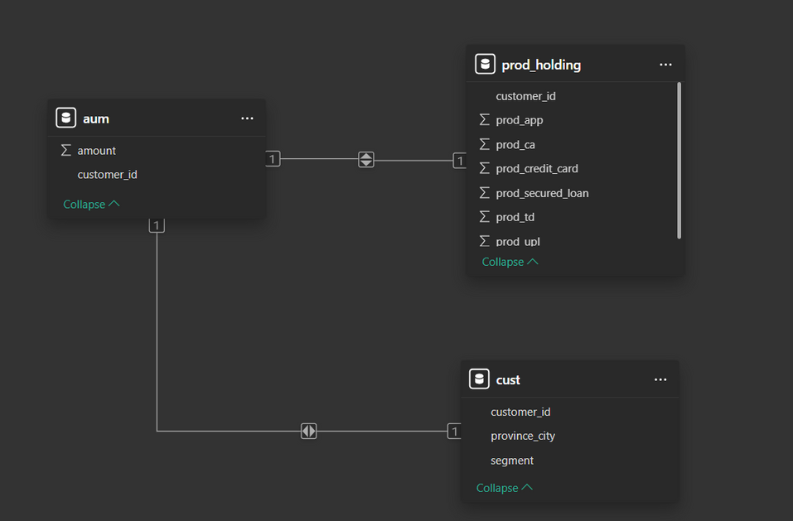

**Description Table**

Table: aum

Information about total assets held by the customer

|  |  |
| --- | --- |
| **Table: aum** |  |
| customer_id | Customer identifier number |
| amount | Total customer assets held |

Table: cust

Information about segments and customer location.

|  |  |
| --- | --- |
| **Table: cust** |  |
| customer_id | Customer identifier number |
| segment | Customer Segmentation |
| province_city | Province/City where Customer live |

Table: prod_holding

Information about the products that customer use.

|  |  |
| --- | --- |
| **Table: prod_holding** |  |
| customer_id | Customer identifier number |
| prob_ca | Payments account products. |
| prob_td | Term deposit products. |
| prob_credit_card | Credit card products. |
| prob_app | Mobile money transfer app products. |
| prob_secured_loan | Mortgage loan products. |
| prob_upl | Unsecured Loan Service. |

# **CHAPTER 3: CUSTOMER SERVICE’S REPORT**

## **3.1 Overview of Customers and Assets:**

The data is updated as a follows:

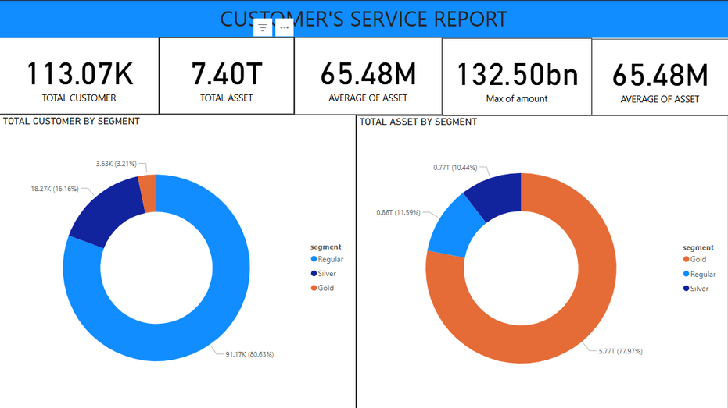

Last March, the Sales team primarily brought in Regular customers; this is also considered a successful step in converting new customers into Regular customers.

The customer group holding the majority of the total assets is still the GOLD customer group.

## **3.2 Customer situation by segment**



A strategy is needed to upgrade Regular customers to Silver and then from Silver to Gold. Create opportunities for the Regular group to experience more of the bank's service incentive program to stimulate them to use it more.

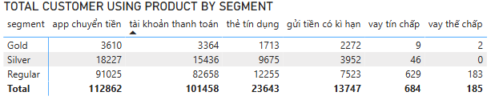

From the service usage behavior of the customer group segment, to increase revenue, you can upsell to the Gold and Silver customer groups using the Mortgage Loan or Unsecured Loan service because these two groups have a relatively small number of customers, while the previously mentioned group has a significant total asset value.

To upgrade customers, the bank should introduce targeted promotional campaigns such as **reduced loan interest rates**, **increased credit limits**, and **exclusive financial planning services**. Personalized offers based on customer spending behavior can also enhance conversion rates.

## **3.3 Customer situation by region:**

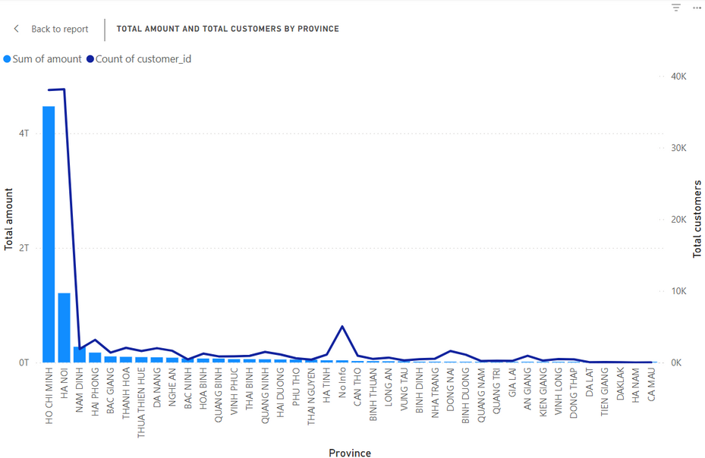

- Although the bank's Head Office is in Hanoi, the number of customers in Hanoi is less, so we need to exploit more customers here.  
- Expanding to exploit more customers in centrally run cities because these cities have economic potential and a lot of trade and commerce.  
- The Hanoi area tends to borrow more Unsecured Loans and Mortgages than customers in Ho Chi Minh, while the HCM area tends to use Credit Cards a lot, so it can exploit new customers and introduce new products above product for them

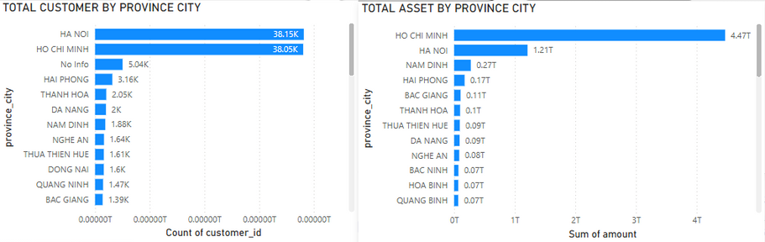

The total number of customers in Hanoi is more than the number of customers in Ho Chi Minh City. However, the total assets of customers in Ho Chi Minh City (4.47T) are nearly 3.7 times larger than Hanoi (1.21T). This proves that customers in Ho Chi Minh City have average assets and a larger number of Gold customers than Hanoi **.**

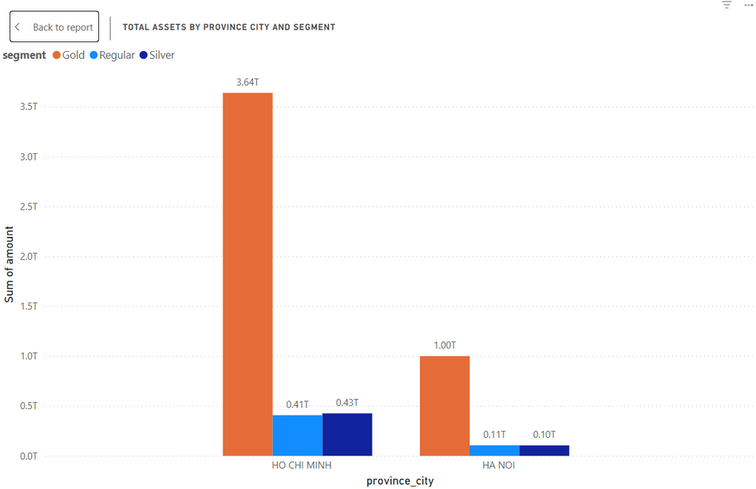

Ho Chi Minh City has more Gold customers than Hanoi, resulting in a higher total asset value.  
Hanoi has more Regular customers, but their average asset value is lower.  
=> To increase revenue, focus on upgrading Regular customers in Hanoi to Silver & Gold.

|  |  |
| --- | --- |
| 0c2b1946484b904042894d362605b84b.png | 485886517628f6e9275da3f24161ba69.png |
| Ha Noi | Ho Chi Minh |

The number of customers using Payment Accounts and Money Transfer App are similar in both regions.

Customers in Ho Chi Minh City use credit cards more than those in Hanoi. This may reflect different spending habits, with Ho Chi Minh City having a tendency to use credit cards more frequently for daily transactions.

**In Hanoi:**

* Encourage credit card usage by reducing annual fees and offering cashback on spending.
* Promote mortgage loan packages by increasing interest rate incentives for **Regular & Silver** customers.

**In Ho Chi Minh City:**

* Expand Credit Card programs, especially with **0% installment payment offers**.
* Leverage the mortgage loan trend by increasing **competitive interest rate loan packages** and reducing **processing fees**.

## **3.4 Customer situation by service:**



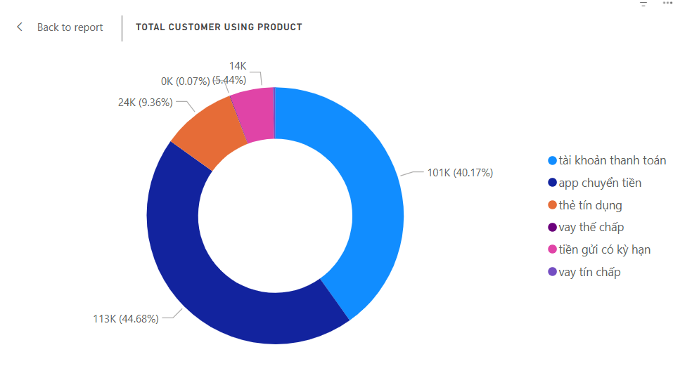

To increase revenue, we need to focus on services that can generate **interest** for banks such as: **Credit Card**, **Time Deposit**, **Unsecured Loan** and **Secured Loan.**

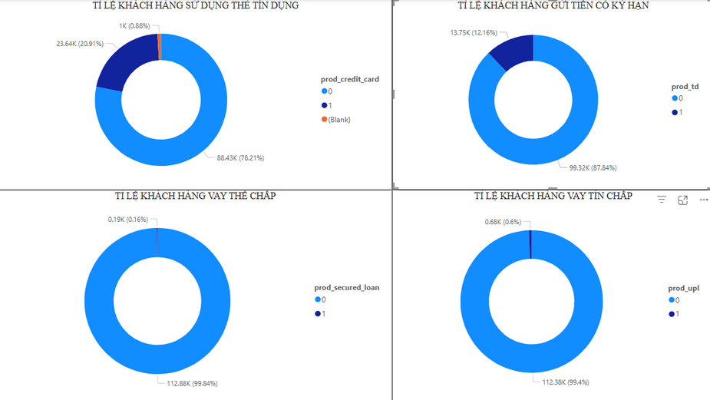

Of the 4 service above, Credit Cards are the most commonly used service due to their convenience, but only 21% of customers use them.  
=> Should offer incentives to new customers when opening cards, installment plans with good or no interest rates through Credit Card.

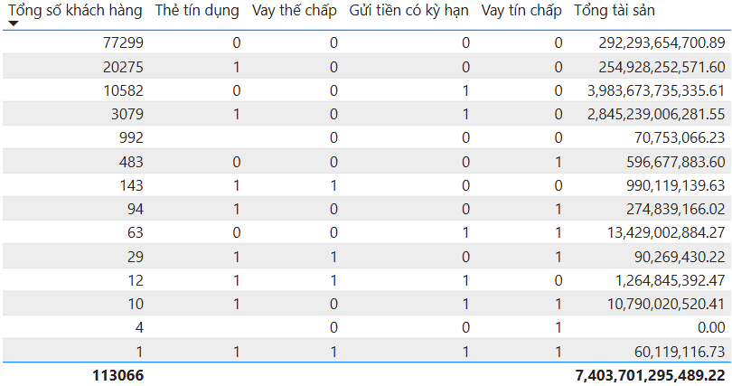

There are many customers who do not use all 4 of the above services

=> Need focus into this customers group.Customers who only use Unsecured Loan services may also have a demand for Credit Cards.